**CSCL4101- AI Lab (30 Marks)**

1. ***MATLAB: (8 marks)***

***Note: post screenshots of the statements and their results after running them on the online MATLAB Software.***

1. Write down the MATLAB syntax to create a matrix , ‘Your First name’ =

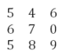 (2 marks)

Answer

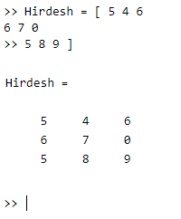

1. Append the following matrices to the matrix A: (2 marks)

F = [ 34, 14, 90]

K = [4, -10, 25]

Answer

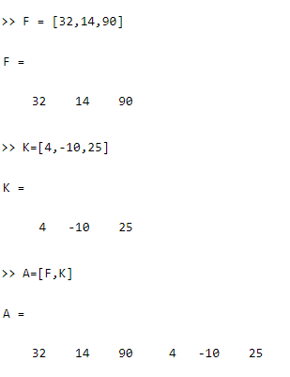

1. Create a **matrix Z** of **size 4 by 4** which has all zeros by using the **zeros** function.

Answer

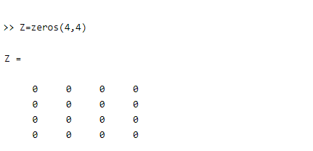

(1 mark)

1. Create a **matrix O** of **size 4 by 4** which has all ones by using the **ones** function.

Answer

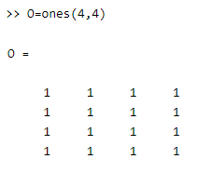

(1 mark)

1. Create a **matrix R** of random integers having numbers ranging from 1-15, having 3 columns and 5 rows. (2 marks)

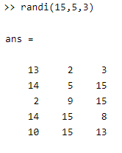

1. ***KNN Algorithm***

Using the KNN algorithm on the given dataset(‘winedatafinal(withnullvalues.csv’) perform the following steps: (18 Marks)

* 1. Load the dataset using PANDAS. (1 mark)

**Answer:**

import pandas as pd

ds=pd.read_csv("winedatafinal(withnullvalues).csv")

* 1. Write a code to view the first five rows of the imported dataset. (1 mark)

**Answer:**

ds.head()

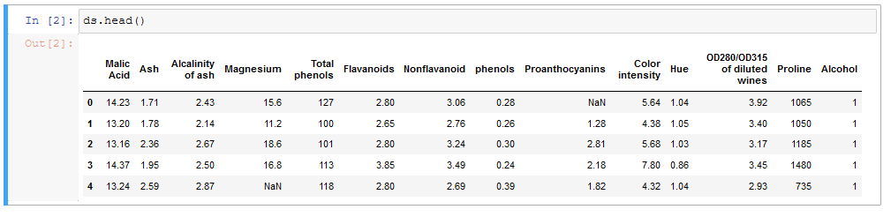

* 1. Perform data cleansing on the raw dataset provided:
     1. Check for null values. (2 marks)

**Answer**

ds.isnull().sum()

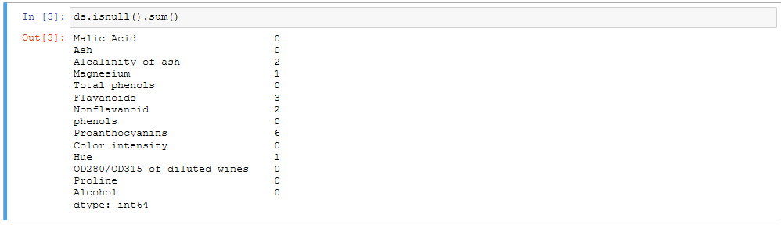

ds["Alcalinity of ash"] = ds.fillna("unknown")

ds["Magnesium"] = ds.fillna("unknown")

ds["Flavanoids"] = ds.fillna("unknown")

ds["Proanthocyanins"] = ds.fillna("unknown")

ds["Hue"] = ds.fillna("unknown")

ds["Nonflavanoid "] = ds.fillna("unknown")

ds.isnull().sum()

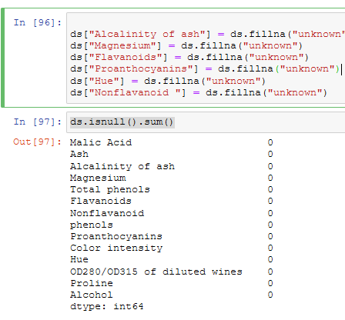

* + 1. Convert the datatypes if needed. (3 marks)

**Answer**

ds.info()

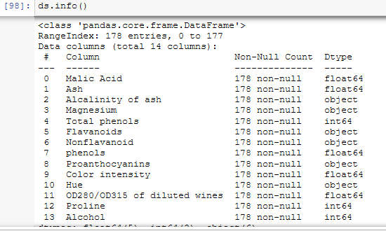

ds["Alcalinity of ash"] = pd.to_numeric(ds["Alcalinity of ash"],errors='coerce')

ds["Magnesium"] = pd.to_numeric(ds["Magnesium"],errors='coerce')

ds["Nonflavanoid "] = pd.to_numeric(ds["Nonflavanoid "],errors='coerce')

ds["Flavanoids"] = pd.to_numeric(ds["Flavanoids"],errors='coerce')

ds["Proanthocyanins"] = pd.to_numeric(ds["Proanthocyanins"],errors='coerce')

ds["Hue"] = pd.to_numeric(ds["Hue"],errors='coerce')

ds.info()

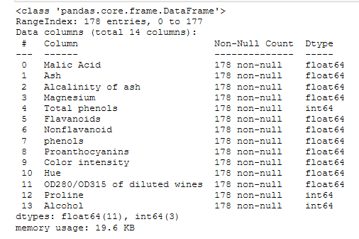

* + 1. Remove the data that is irrelevant to the prediction model. (3 marks)

**Answer**

No need to remove data all columns are import in identifying different variants of alcohol

* 1. Break the dataset into attributes (2 marks)

df_x = ds.iloc[:, :-1].values

df_y = ds.iloc[:, 13].values

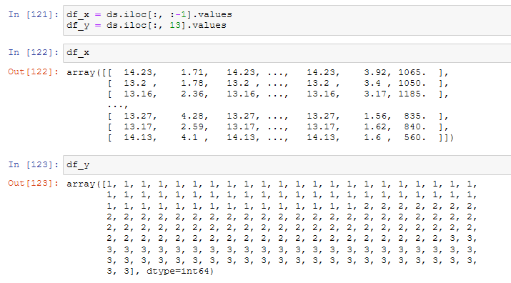

* 1. Write down the code to only print the attributes. (1 mark)

Answer

attributes=df_x

print(attributes)

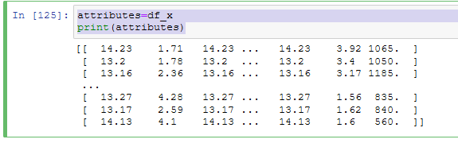

* 1. Write down the code to print the label only. (1 mark)

label=df_y

print(label)

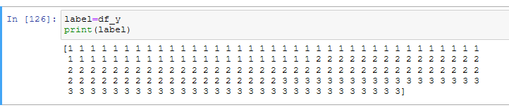

* 1. Break the dataset into training and testing data while keeping the

testing data as 30%. (1 mark)

Answer

X_train,X_test,y_train,y_test = train_test_split(attributes,label,test_size=0.30)



* 1. when applying the KNeighborsClassifier, keep K=the last digit of your Registration Number. For example if the registration number is 1812289, then k=9.

Answer

classifier=KNeighborsClassifier(n_neighbors=4)

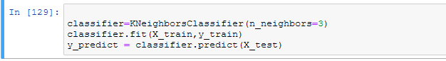

(1 mark)

* 1. Predict the values of the label of the testing data. (1 mark)

print(y_test)

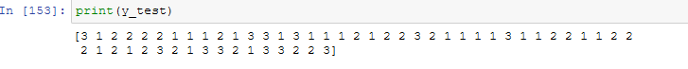

* 1. Print the predicted values. (1 mark)

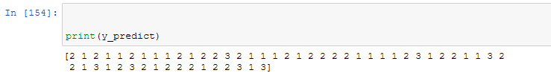

1. ***Data Processing:***

Use the ‘Details.csv’ dataset, and apply all data cleaning practices to make the data ready for further processing. (4 marks)

Answer:

Ma’am I was not able to import the csv file. CR messaged that this part would be compenstated for those that we not able to import